**Screenshots of Task Performed**

Flight table

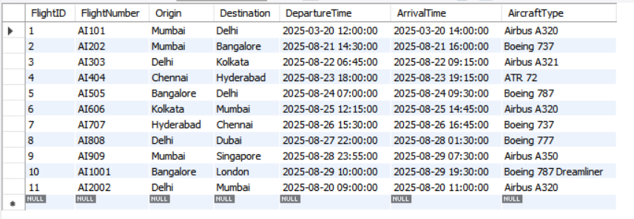

Customer Table

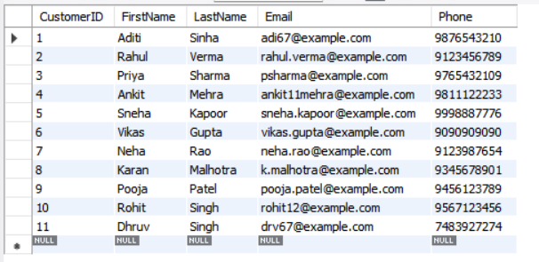

Inventory Table

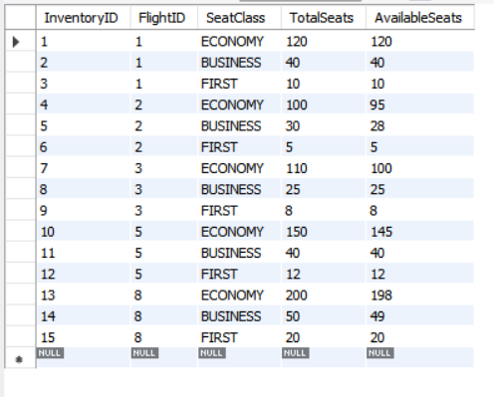

Bookings Table

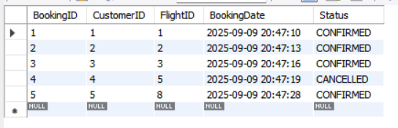

Booking_Seats

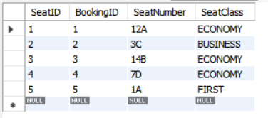

Search Flights

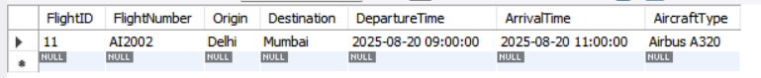

Check Available Seats

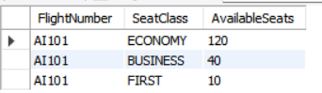

Booking Summary Reports

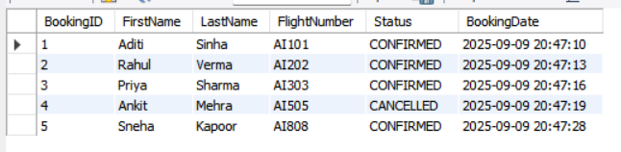

Triggers

